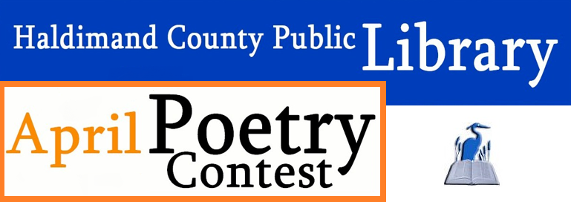
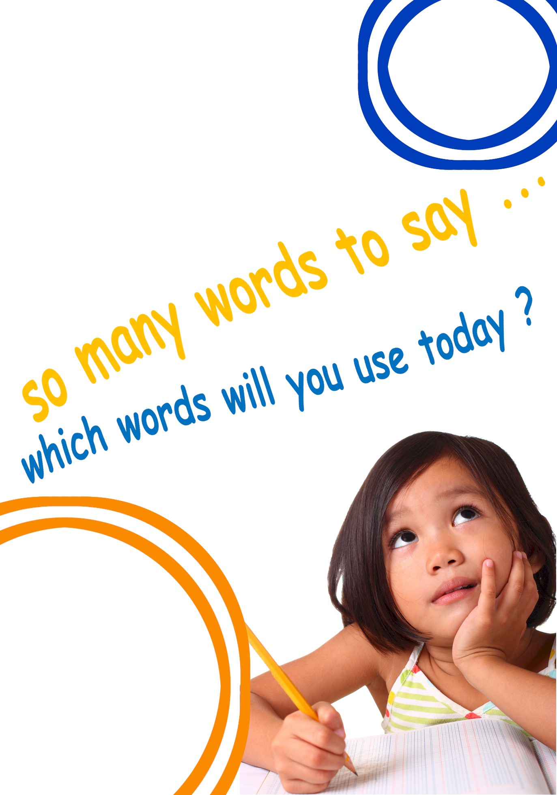

Submit your original poetry for a chance to win:
1st $50
2nd $35
3rd $20

Theme:
Spirituality
Contest ends April 30th
Contest entry form along with
full instructions are available at
your local library branch or online.

Thank you to our
generous sponsors!

