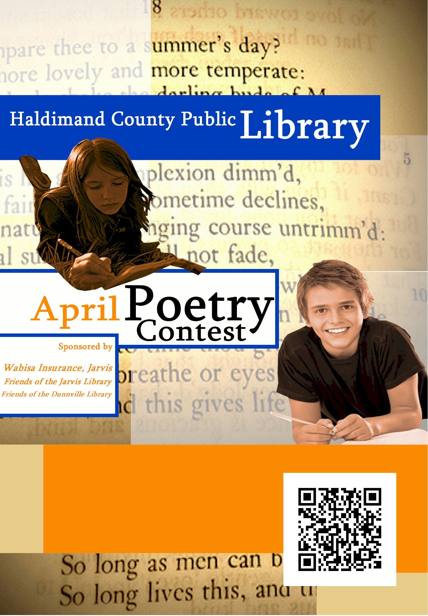
Submit your original
poetry for a chance to
win: 1st $50
2nd $35
3rd $20

Contest runs
April 1st to
April 30th

Theme:
Spirituality

Contest entry forms along with contest rules are available at your local library branch or online at www.haldimandlibrary.ca

Prize Categories:
Primary (gr.K-3)
Junior (gr. 4-6)
Intermediate (gr.7- 10)
Senior (gr.11-12)
Adult (age 18+)

Thank you to our generous sponsors!

